**How we will run Simple” Java file” without any Build Tool and GitHub hook:**

1. First open Jenkins by using <http://instance-ip:8080>
2. Click on “**New Item**” and select “**Freestyle project”** click on **OK**
3. In “General section select “GitHub project”

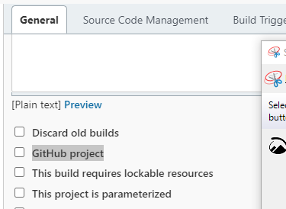

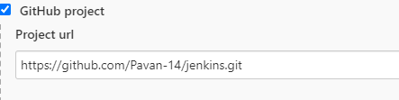

1. Go to “Source Code Management” section select “GIT”

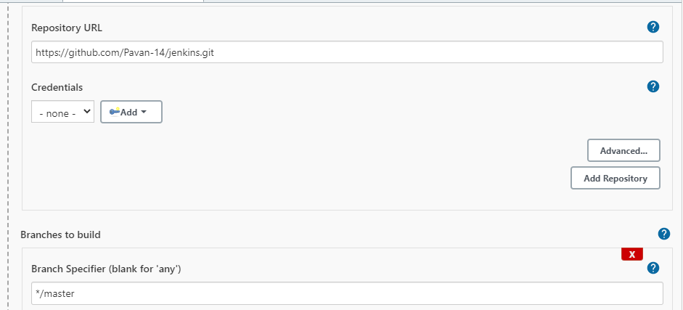

Note: based your branch you need to change branch name.

1. In “BUILD” section

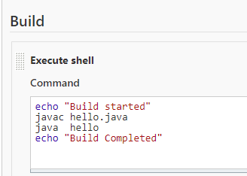

Hello is class name in java code:

**class hello {**

1. Go to “Post-build Actions” section

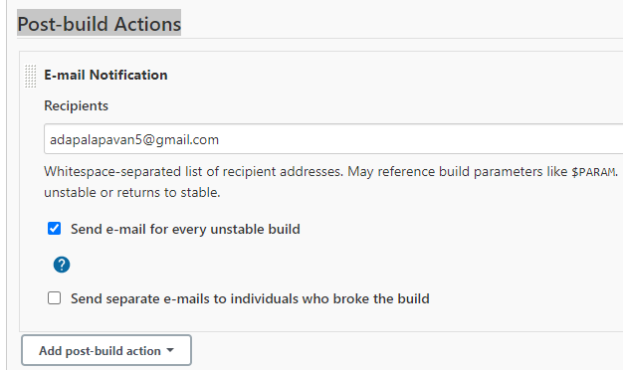

1. Click on Apply and Save.
2. Click on “Build Now”.

By using” Build Trigger”:

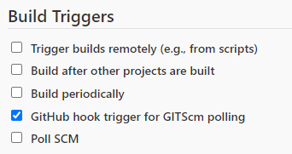

By using GitHub hook any changes in repository will trigger and Jenkins’s build is executed. For this we will add webhook in Git repo in below format” http://54.205.229.44:8080/github-webhook/”.

**How we will run Simple” Python file” without any Build Tool and GitHub hook:**

Only change step 5:

echo "build started"

python good.py ====> shell scripting

echo "done"

**How we will run Simple” Python file” with GitHub hook and without any Build Tool:**

By using” Build Trigger”:

By using GitHub hook any changes in repository will trigger and Jenkins’s build is executed. For this we will add webhook in Git repo in below format” http://54.205.229.44:8080/github-webhook/”.

